**BIT 2305 Human Computer Interface**

**Take-away CAT MARKS: 40**

Handing out date (by email): Wednesday, 3rd April 2024

Handing in date (by email): Wednesday, 10th April 2024

**INSTRUCTIONS**

- All the questions and all the parts are compulsory

- Each student should do the CAT ***as an individual*** and email the done CAT to me by the end of ***Wednesday, 10th April 2024*** at [skimani@scit.jkuat.ac.ke](mailto:skimani@scit.jkuat.ac.ke)

- The done CAT should be an MS Word document

**PART A**

1. An adaptive or adaptable system should ideally consist of: a domain model, a user model, and an interaction model. Define each of those models as used in HCI (3 marks)
2. Besides counterbalancing, name *two* other methods that can be used to minimize transfer of learning effects in a within-subjects experimental setup. (2 marks)
3. Highlight any *three* properties or characteristics of virtual reality. (3 marks)
4. *DrivExcel* applicationprovidesdrivers with navigation support while driving. It specifically provides drivers with the possibility to use either a map user interface or a voice user interface. Consider that an evaluator would like to set up an experiment to assess whether drivers reach destinations faster when using the map user interface than when using the voice user interface.
   1. Define the following terms: independent variable and dependent variable. (2 marks)
   2. After getting the data of the experiment, what can one do about the data before going ahead and performing statistical of the same? (2 marks)
   3. From the above situation, determine: the independent variable(s), the level(s) of the independent variable(s), and the dependent variable(s). (4 marks)
5. The following diagram shows an example of a model that can be used in designing a corresponding interactive system:

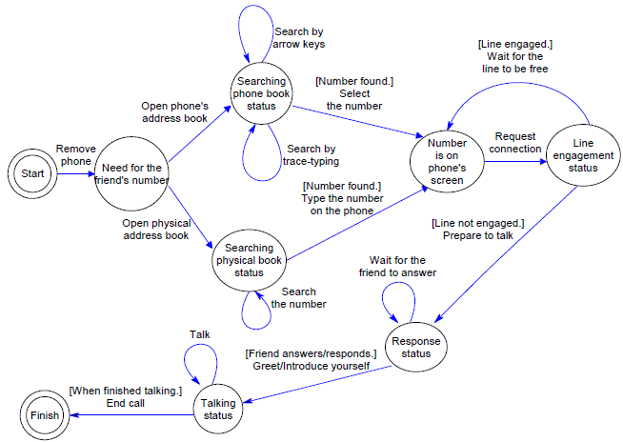

1. What is this type of model referred to as? (1 mark)
2. Give a brief description of the interactive system that can possibly be designed using the above diagram. (3 marks)

**PART B**

1. Discuss any *three* advantages and any *three* disadvantages of Heuristic Evaluation. (Please be as specific as possible in your discussion.) (6 marks)
2. In what ways do multimodal interfaces facilitate superior error handling, when compared with the traditional unimodal interfaces? (4 marks)
3. Differentiate between the *Gulf of Execution* and the *Gulf of Evaluation*. (2 marks)
4. Describe any two desirable characteristics or requirements of prototyping tools. (2 marks)
5. Highlight any *two* properties or characteristics of virtual reality. (2 marks)
6. Computer-Supported Cooperative Work (CSCW) refers to collaboration between individuals via computing technologies. CSCW systems are built to allow collaboration between humans via the computer. Two important features of CSCW systems are: (i) the mode of interaction they support and (ii) the geographical distribution of the users. Decompose the two features further and consequently describe the emanating four-category classification of CSCW systems. (4 marks)